

Leicestershire Nutrition

and Dietetic Services

**Ice lolly ideas!**

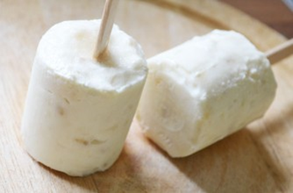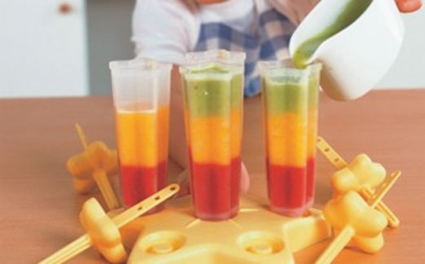

**Traffic light ice lollies**

**Ingredients:**

½ small watermelon

3 large ripe peaches

5 large ripe kiwi fruits

3 tbsp. water

**Method**

For red layer

1. Cut melon and remove seeds then Puree with a hand blender
2. Pour puree melon into ice lolly moulds 1/3 full
3. Leave in the freezer for 1 ½ hours

For yellow layer

1. Remove skin and slice peaches, puree with a hand blender
2. Pour onto frozen red puree, mould should be 2/3 full
3. Freeze until solid

For green layer

1. Peel and slice kiwi fruits, blend with the water
2. Sieve puree to remove seeds
3. Pour puree to fill the lolly moulds
4. Freeze until solid

**Banana & Yoghurt**

**Ingredients:**

160g low fat natural yoghurt

1 x ripe banana

**Method:**

1. Mash the banana until smooth
2. Mix mashed banana with yoghurt
3. Spoon/pour mixture into ice lolly moulds

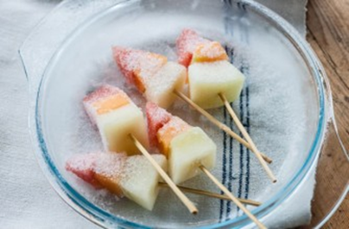

**Tropical fruit rockets**

**Ingredients:**

½ watermelon

½ cantaloupe melon

½ honeydew melon

**Method:**

1. Cut the melons into slice (1-2cm wide)
2. Cut the slices into bite size triangles
3. Put alternative melons on to skewers until full
4. Line a tray which parchment paper and places skewers onto tray
5. Freeze for 3 hours or overnight